**Brooklyn torah gazette**

**For parshas ki savo 5782**

Volume 6, Issue 51 (Whole Number 306) 21 Elul 5782/ September 17, 2022

**Jewish Community Mourns the Loss of Master Askan**

**Reb Yanky Meyer, zt”l**

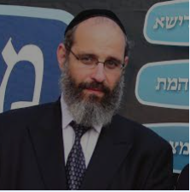

The New York Jewish Community mourns the untimely petirah on Thursday night, 13 Elul/September 8 of the great askan – Reb Yanky Meyer, zt”l who founded Misaskim, an organization that has brought comfort and help to hundreds of thousands of mourners in America’ largest Jewish community. A more complete report will appear (G-d willing) in next week’s edition of the Brooklyn Torah Gazette.

**British Jewry Mourns the**

**Death of Her Majesty**

**Queen Elizabeth II**

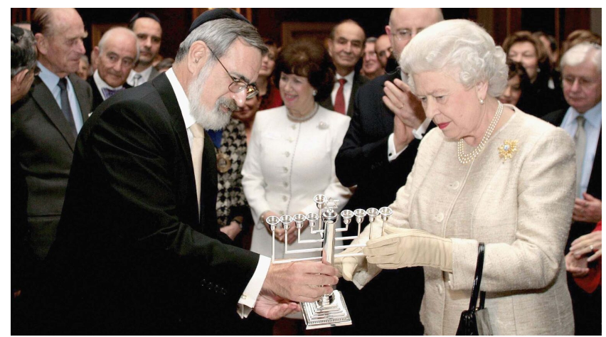

**The late British Chief Rabbi Jonathan Sacks gives the late Queen Elizabeth II a menorah at a reception at St. James’ Palace in London to mark the 350th anniversary of the re-establishment of the Jewish community in Britain, Nov. 28, 2006.**

([JTA](http://www.jta.org/)) — The reign of Queen Elizabeth II, Britain’s longest-serving monarch who died Thursday at 96, encompassed the grief and the redemption of 20th century British Jewry, as well as their evolution in British society from exoticized outsiders to inside players and leading figures.

The passing of the queen, who was surrounded by her children and grandchildren, has launched a period of widespread mourning and uncertainty among Britons, who are already unsettled by a battered economy and political upheaval spurred by a departure from the European Union and a quick succession of three prime ministers.

Among other things, Elizabeth’s life spanned several of the century’s most consequential wars, the advent of the internet and the COVID-19 pandemic. She inherited the throne in 1952, after a rushed series of devolutions across the British empire, including the ouster of Britain from Mandatory Palestine in 1948, which led to the founding of the state of Israel.

In the postwar sheen of the defeat of fascism, monarchies seemed increasingly obsolete over time, but Elizabeth oversaw a transition to symbolism that preserved the crown’s pomp and standing throughout British society.

British Jewish leaders echoed the sentiments expressed by dignitaries and presidents across the globe on Thursday.

“No words can fully describe the extent of our nation’s loss,” the Board of Deputies of British Jews said in a statement. “Her Majesty’s wisdom, benevolence and dedication to duty served as an inspiration to generations of British citizens, including our community. May Her memory be for blessing.”

Reprinted from the September 8, 2022 dispatch of the JTA (Jewish Telegraphic Agency) that was written by Ron Kampeas.

**King Charles III Was Circumcised by Jewish Mohel, Cherishes UK Jews**

**By** [**David Israel**](https://www.jewishpress.com/author/di/)

When Philip Arthur George, the first child of Princess Elizabeth and Philip Mountbatten, was born, on November 14, 1948, his mother hired Rabbi Jacob Snowman, a well-known London physician and mohel in December 1948 to circumcise her son.

Snowman circumcised other members of the British nobility and Royal Family, and the princess was reportedly highly satisfied with the Rabbi’s work. The royal family tradition of hiring Jewish mohels to circumcise their sons goes back to Queen Victoria. However, it was reported that this fine tradition was interrupted in 1982 after the birth of Prince William, because his mother Diana, the Princess of Wales, did not approve.

Rabbi Snowman’s brother, Emanuel Snowman, married into the Wartski family of jewelers and for generations provided the royals with jewelry, including the Welsh gold wedding bands for Charles and the former Camilla Parker-Bowles, and the bands worn by Prince William, Duke of Cambridge and the former Kate Middleton.

Prince Charles became King Charles III the moment his mother, Queen Elizabeth II, passed away on Thursday, September 8. There will be a coronation in a few weeks, but its purpose will only be to ratify his rule – he already has the title and Camilla is already Queen Camilla, which the late Queen specified in her Accession Day message of February 5, 2022.

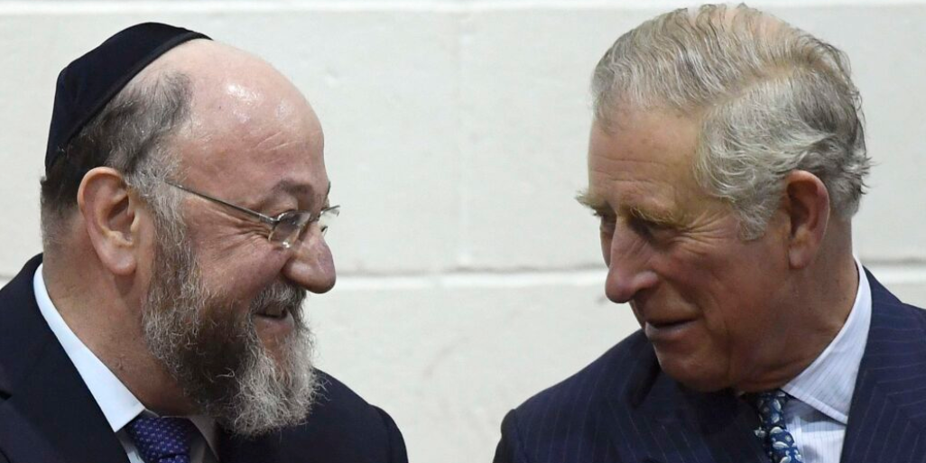

**King Charles III (then Prince Charles of Wales) meeting the British Chief Rabbi at the Jewish Orthodox school Yavneh College in London, England on February 1, 2017.**

Meanwhile, the uncircumcised Prince William does not automatically become the Prince of Wales, and it will be up to the new king to give him the title.

King Charles III’s grandmother, Princess Alice of Battenberg, who lived in Greece was one of the Righteous Among the Nations. In 1943, the German Army occupied Athens and rounded up the small group of Greek Jews that hadn’t been deported to Auschwitz yet. The princess hid the Jewish widow Rachel Cohen and two of her five children, who were hiding from the Gestapo.

**The King’s Grandmother is Buried in Jerusalem**

Prince Charles, who visited her tomb in Jerusalem in January 2020, said she was a source of “immense pride” for him and the royal family.

The visit to his grandmother’s tomb was part of Prince Charles’s official visit to Israel, to join many other world leaders at the World Holocaust Forum in Jerusalem commemorating the 75th anniversary of the liberation of Auschwitz. Prince Charles’ office issued a statement saying January’s trip “will be the first time that the prince has undertaken a program of engagements in Israel or the Occupied Palestinian Territories.”

Ah, well.

Prince Charles also visited Israel for Yitzhak Rabin’s funeral in 1995, and Shimon Peres’s in 2016.

On December 6, 2019, Prince Charles delivered a speech he titled, [**The special and precious connection between Jewish community and the Crown**](https://www.thejc.com/comment/comment/prince-charles-praises-special-and-precious-connection-between-jewish-community-and-the-crown-1.494071), at a reception in Buckingham Palace. He said, among other things: “In every walk of life, in every field of endeavor, our nation could have had no more generous citizens, and no more faithful friends.”

He also said:

**“The connection between the Crown and our Jewish Community is something special and precious. I say this from a particular and personal perspective because I have grown up being deeply touched by the fact that British synagogues have, for centuries, remembered my Family in your weekly prayers. And as you remember my Family, so we too remember and celebrate you.”**

**The Jewish Prime Minister – Benjamin Disraeli**

And:

**“Benjamin Disraeli, of course, the great Prime Minister, although baptized as a child, never denied his Jewish heritage, describing himself to my great-great-great grandmother, Queen Victoria, as: ‘The blank page between the Old and the New Testaments!’ When taunted by a Member of Parliament, he answered: ‘Yes, I am a Jew, but when the ancestors of The Right Honorable Gentleman were living as savages on an unknown island, mine were priests in the Temple of Solomon!’”**

On April 28 this year, Prince Charles [visited](https://www.thejc.com/news/community/prince-charles-praises-world-jewish-relief-staff-as-he-meets-ukrainian-refugees-the-charity-has-helped-6l1VjZCQmZfu8rsxlEzhAc) the headquarters of the World Jewish Relief agency in Golders Green, London, and praised its charity work in Ukraine, saying: “What a difference has been made.” The prince told one refugee from Odessa that was praying for the end of the war, and she described him as “a righteous gentile.”

Good job, Rabbi Snowman!

*Reprinted from the September 9, 2022 website of The Jewish Press.*

**Rav Avigdor Miller on**

**Voting with Wisdom**



**QUESTION: Should a yeshiva bachur register to vote?**

**ANSWER:** Should a yeshiva man register to vote?

It depends.  If he knows how to vote, he should.  If he doesn’t, he shouldn’t.

Now sometimes it’s a question between this crook and that crook and so it’s a waste of time.  But if you have a special intention by voting then by all means, because we should put our weight in the right direction.

Today, it’s important if possible to throw our weight against the liberals.  Whatever you can do against liberals.  It’s a great tragedy that the Jews are not apprised of the danger.  The liberals are endangering our safety.  Jewish liberals are undermining the country.

And whatever you can do to vote against a man who is against capital punishment, do it. If a man is against capital punishment, vote against him!  If a man is for homosexuals, vote against him! If a man is for E.R.A., vote against him! Vote only for those who want to uphold the standards that the country lived by until now.  Vote for those who want to make America strong.  Armaments! Not disarmaments.

Vote against those who want to spend more money for welfare. It’s a very wicked thing President Carter did; he made a national cabinet for education and he put a woman at the head of it.  Up until now, anybody who wanted to contaminate the education system did so through state and city channels.  Now it’s going to be done on a national scale.  Carter is a liberal and he started something new.  It’ll cost a pile of money; millions; billions it will cost and all those billions will go towards corrupting America.

Whatever we can do to unseat the liberals, by all means.

*Reprinted from the September 5, 2022 email of Toras Avigdor (Tape #289 – October 1979)*

**The Mitzvah of a Jew to**

**Walk in His (G-d’s) Way**

**From the Talks of the Lubavitcher Rebbe**

**Rabbi Menachem Mendel Schneerson, Zt”l**

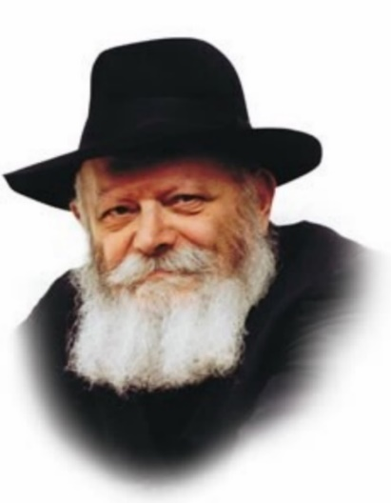

As Maimonides enumerates the Torah's 613 commandments, general commandments such as "You shall be holy" or "You shall keep My laws" are not, as a rule, considered mitzvot in their own right. Rather, these are classified as broad directives encompassing all of Judaism.

It is therefore surprising, at first glance, that the commandment which appears in this week's Torah portion, Ki Tavo, "You shall walk in His ways," is classified as a positive mitzva, requiring the Jew "to emulate the Holy One, Blessed Be He." "Just as G-d is gracious, so shall you be gracious. Just as G-d is merciful, so shall you be merciful. Just as G-d is pious, so shall you be pious," Maimonides writes. Indeed, the commandment implies that a Jew is required to emulate G-d to the best of his/her ability, at all times and in all circumstances.

But why is this commandment different from all other general statements in the Torah, to the point that it is characterized as a separate mitzva? What does the verse "You shall walk in His ways" entail that other similar commandments do not?

To explain:

Maimonides classifies "You shall walk in His ways" as a distinct commandment because it contains a unique innovation not found in any other general directive in the Torah. This innovation is alluded to in the specific use of the word "walk," which implies an ongoing and perpetual sense of motion.

**The Difference Between the Soul of a Jew and an Angel**

One of the differences between the soul of a Jew and an angel is that angels are stationary beings, fixed in their spiritual positions, whereas the Jewish soul constantly ascends from one spiritual level to the next. The Jew is constantly in motion, reaching higher and higher spiritual heights by virtue of his actions.

It sometimes happens that a Jew may observe mitzvot, yet he remains on the same spiritual rung as before. His performance of the mitzva did not cause him to progress or ascend any further. The commandment "You shall walk in His ways" comes to teach us that a Jew must never be stagnant, that his performance of mitzvot must always lead to an improvement of his overall spiritual condition.

How are we to accomplish this? By observing the Torah's commandments solely because they are "His ways" -- because of our desire to emulate G-d. For when we do, our spiritual ascent to higher and even higher levels of G-dliness is assured.

*Reprinted from Issue 486 of L’Chaim for Parshas Ki Tavo 5757/1997. Adapted from Likutei Sichot, Volume 4.*

**Rosh Hashanah is Coming Quickly**

One year, shortly after Pesach, R’ Aharon Leib Shteinman was in bed, talking out loud to Hashem, begging for good decrees for Klal Yisroel. “Hashem” he implored, “please listen to me, even though Rosh Hashanah is approaching very quickly.”

His grandson told him, “Rosh Hashanah is still a few months away!”

“The last few months flew by so quickly,” R’ Aharon Leib pointed out. “So, too, the time between now and Rosh Hashanah will also elapse quickly. I really must start doing teshuvah!” (Reb Aharon Leib)

*Reprinted from the Parshas Ki Seitzei 5782 email of The Weekly Vort.*

**Rabbi Berel Wein on**

**Parshat Ki Tavo 5782**

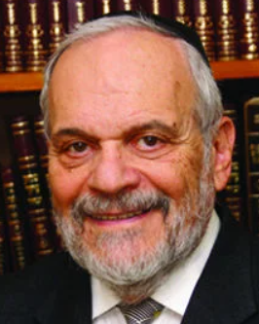

One of the bitterest curses that the Torah describes in the *tochacha,*which forms a major portion of this parsha, is that all our efforts will be for naught, all our ambitions, ideas and struggles ultimately pointless and of no lasting value, unless we build strong family ties and encourage harmony. There are relatively few ways that we can make our mark on the world and our lives, unless we are able to see the accomplishments of others, ideally through our offspring and close relatives.

That is the reason that family relations, especially parent-child relationships, are so delicate and emotional. Even if one feels that one’s efforts in life have been successful, the verdict on our achievements is yet to be rendered and that depends upon the continuing success of our future generations. Therefore the words of the *tochacha* are truly frightening, for they portend that future generations can undo all previous achievements of their predecessors. We are all too bitterly aware that this is true especially in our generatrions.

This inconsonance between generations is emphasized further in the *tochacha* when the Torah describes “that your children shall be given to another nation and that you will be powerless to prevent it.” The Torah refers here not only to actual enslavement and imprisonment of one’s children but it also implies being given to a foreign, non-Jewish culture and way of life. The effects of the secularization of the youthful generations of Eastern European Jewry and of American and Israeli Jewry are so serious as to be almost catastrophic.

Our generation and times are left to pay the bill for those previous defections from Jewish life. And, what the appeal of false ideals that overwhelmed the Jewish street then did not destroy, the Holocaust, described in minute detail in the *tochacha*– completed. If it were not for G-d’s promise that ends the *tochacha,* that Israel will survive and rejuvenate itself, we would almost be without hope or comfort. But it is the sad fact that the *tochacha,* in all of its awful prophecies and events, has literally taken place before our eyes. And, this paradoxically gives us the hope and promise for the better times that G-d’s promise extends to us.

As we contemplate the shambles of the *tochacha*that surround us currently, we may take hope in the future- that the times of peace, spiritual accomplishment and serenity of soul will also be literally fulfilled in the great and good year that is about to dawn upon us and all of Israel.

Shabat shalom.

*Reprinted from the current website of rabbiwein.com*

**Thoughts that Count**

Whenever a person's deeds exceed his wisdom, his wisdom will endure (Ethics, 3:10)

This Mishna can also be applied to the area of education. A school should endeavor to impart wisdom and at the same time train its students to do good deeds. In fact, the primary focus should be on good deeds, for through them the knowledge will thrive. *(Biurim L'Pirkei Avot)*

Everything is foreseen, yet freedom of choice is granted (Ethics, 3:15)

Every person has the potential to fulfill his personal destiny, but the choice to fulfill that destiny is his alone. No one can stand in his way, nor is there anyone compelling him. *(Likutei Sichot)*

*Reprinted from the 5757/1997 Ki Tavo issue (#486) of L’Chaim Weekly, a publication of the Lubavitch Youth Organization.*

**The German President’s Stunning Act of Repentance**

**By**[**Sara Yoheved Rigler**](https://aish.com/authors/48865432)

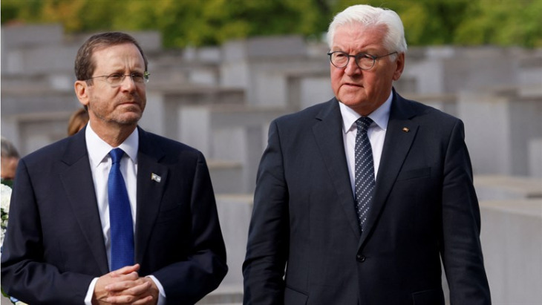

***In Munich. German President Frank-Walter Steinmeier (right) with Israeli President Yitzchok Herzog***

In the Jewish calendar, tis the season to do *teshuvah*— to repent for past wrongdoings. Rabbis and spiritual mentors are discoursing on the steps of *teshuvah* outlined by Maimonides, the great 12th century expositor of the concept. But, ironically, it is the President of Germany who this week gave the world a stunning example of repentance.

The weeks leading up to the 50th anniversary of the 1972 massacre of 11 Israeli athletes at the [Munich Olympics](https://aish.com/we-were-at-the-1972-munich-olympic-games/) were fraught with dissension. The families of the victims announced that they would boycott the commemorative ceremony because the German government had for 50 years lied to them, refused to share the archive of thousands of files and hundreds of forensic pictures that revealed what had happened to their loved ones, and offered a pittance of a financial compensation.

Although it was Arab terrorists who had murdered the athletes, the families of the victims rightly accused the Germans of failure to protect the athletes (even refusing Israeli security offers), the botched rescue operation, and the cold, mendacious way the German government handled the affair afterwards.

Finally, German President Frank-Walter Steinmeier offered to fly to Israel to work out an agreement, and the families agreed to attend the ceremony.

In Munich, amidst the dark grief of commemorating the tragedy, a beacon of light shone forth from an unlikely source. President Steinmeier spoke as if he had studied Maimonides’ [five steps of *teshuvah*](https://aish.com/four_steps_to_change/).

**1. The first step of *teshuvah* is admitting one’s failure, without rationalizations or excuses.**

Here’s how President Steinmeier began his address:

Today’s act of remembrance can only be sincere if we are prepared to recognize painful facts – if we acknowledge that the story of the Olympic attack is also a story of misjudgments and of dreadful, fatal mistakes: of, in fact, failure. We are talking about a great tragedy and a triple failure.

The first failure regards the preparations for the games and the security strategy; the second comprises the events of Sept. 5 and 6, 1972; and the third failure begins the day after the attack: the silence, the denial, the forgetting.”

**2. The second step is to regret one’s wrong action.**

President Steinmeier acknowledged that it was Germany’s responsibility as the host of the games to protect all the athletes, especially those from Israel. In a poignant admission, tinged with remorse, he confessed:

There were survivors of the Shoah among the athletes and their coaches. Their safety had been entrusted to us. What a great vote of confidence it was to take part, after the crimes against humanity of the Shoah, in Olympic Games hosted by the country of the perpetrators. … We were not prepared for an attack of this kind, and yet we ought to have been; that, too, is part of the bitter truth…. Honored family members, I cannot fathom what suffering, what pain you’ve been through, how can life go on. For five decades, that gnawing pain has been with you.

**3. The third step is undertaking to act differently in the future.**

After five decades of Germany denying the existence of the archives and evading their obligation to the victims’ families, President Steinmeier announced that the German government would establish an Israeli-German commission of historians to “shed light onto that dark chapter.”

Directly addressing the families, he declared: “You have a right to finally know the truth, to finally receive answers to the questions that have tormented you for decades. And they include the question of why you were left alone with your suffering, your pain, for so long.”

**4. The fourth step (if another person has been hurt) is to ask forgiveness.**

President Steinmeier did exactly that, declaring: “As the head of state of this country and in the name of the Federal Republic of Germany, I ask your forgiveness for the woefully inadequate protection afforded to the Israeli athletes at the Olympic Games in Munich and for the woefully inadequate investigation afterwards.”

**5. The fifth step (if property is involved) is to make restitution.**

The German government, after its long refusal to do so, offered the victims’ families a compensation package of 28 million dollars.

*Teshuvah*, our sages assert, actually changes the past. The damage remains, but the person who has done genuine *teshuvah* is no longer the same agent of wrongdoing. By transforming oneself, through admitting, regretting, resolving to act differently in the future, apologizing, and making restitution, the progenitor of the evil has become an agent of light.

President Frank-Walter Steinmeier deserves credit for showing us all how to do it.

*Reprinted from the September 8, 2022 dispatch on the website of aish.com*

**The Legacy of Rabbi Gedaliah Anemer, zt”l**

Rabbi Gedaliah Anemer zt'l was born in Akron, Ohio (on 3/19/1932, 11 Adar 2, 5692) to Reb Zev and Rivka Anemer. His early schooling was at Tiferes Yerushalayim in New York. He attended Telshe Yeshiva from 1944-1956, where he was an elite talmid and acknowledged as expert in all areas of Shas and Shulchan Aruch.

He was a close talmid of Rav Elya Meir Bloch. Rabbi Anemer received smicha in 1952 and became Rosh Yeshiva of the Boston Rabbinical Seminary, a joint venture of Lakewood and Telshe Yeshiva.

In 1956, Rav Anemer and his wife moved from Boston to Washington and he became rov of the Young Israel when it moved into its first building on Eastern Avenue in Riggs Park.. After a few short years, the demographics of the Riggs Park community threatened the existence of the shul, which was losing members to other neighborhoods.

Under the leadership of Rav Anemer, the shul created a branch in the suburbs where there was not yet a frum shul. It was in 1962 that Young Israel Shomrai Emunah relocated to the leafy suburb from Washington. (“There was no Orthodox community until we moved out here,” Rav Anemer once remarked. “We started davening in my house. A small shul was built a year later.”) and the seeds of what was to become the Silver Spring Jewish Community were planted.

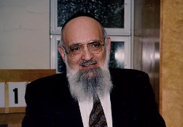

In 1963, Rabbi Anemer founded The Yeshiva of Greater Washington, consisting of both girls and boys divisions. Over the next 45 years, while serving as the Rosh HaYeshiva, he gave a daily advanced shiur in Gemora in the Boys' High School and likewise taught many classes in the Girls' High School. He molded the lives of thousands of talmidim and talmidos and was truly revered and loved by all.

Things weren’t always easy as Rav Anemer built up his kehillah, but he was steadfast in his desire to bring Yiddishkeit to the Jews in Washington. As rosh yeshiva of Yeshiva of Greater Washington and av beis din of the Rabbinical Council of Greater Washington, he served the community with great dedication.

Rabbi Anemer was a dynamic orator and a master educator, who spiritually and intellectually impacted the lives of thousands with his shiurim in Tanach, Gemora, and Halacha. He was niftar on April 15, 2010, Rosh Chodesh Iyar. Yehi Zichro Boruch (Edited by his son, our Daf Yomi magid shiur, Rabbi Yisroel Anemer amo"sh)

*Reprinted from the Parshat Ki Savo 5782 email of Reb Yedidye Hirtenfeld’s whY I Matter parsha sheet for the Young Israel of Midwood in Brooklyn.*

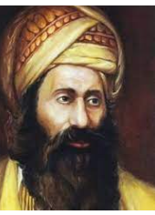

**Ben Ish Chai Manuscript to be Auctioned in Jerusalem**

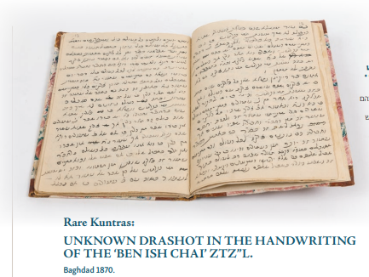

**Reprinted from the Fifth Judaica Auction (09/13/2022) of Taj-Art**